**Config:**

git config --global user.name "YOUR_USERNAME"

git config --global user.email "karan509@gmail.com"

git config --global --list # To check the info you just provided

**To change configured username and email**

git config –global –edit

**When you create a directory in localmachine firstly type this command:**

git init

**To make file, type this command:**

touch filename

e.g. touch index.html

**To open file, type this command**

notepad filename

e.g., notepad index.html

**To change the commit, type this command**

git revert HEAD

**To delete file, type this command**

git rm <filename>

**To Add file to Staging Area**

git add filename

e.g. git add index.html

git add filename1 filename2 => two file

e.g. git add index.html contact.html

git add . => All file

**To check changed files' status**

git status

**To commit the changes**

git commit -m "Message"

git log => View commit history

git log --oneline => view in oneline

**Link the repository**

git remote add origin https://github.com/girirajrawat33/newrepo123.git

**To push our code to github**

git push origin master or git push -f origin master

**To copy/clone github repository to computer file**

Firstly open your favourite browser and type github.com

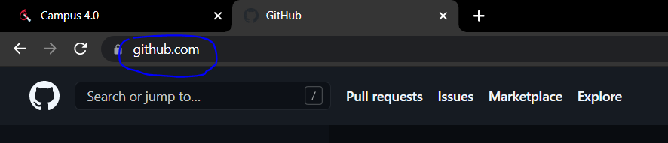

Then click on your repository as you want to clone in your computer

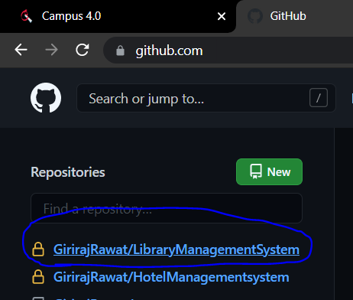

Then click on code

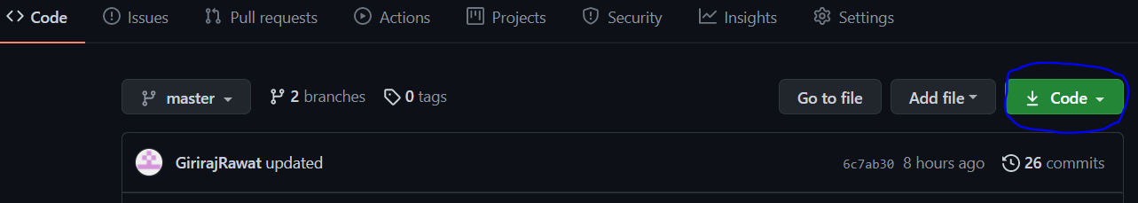

Copy url

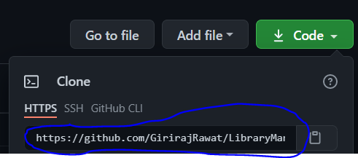

Finally clone your repository in your computer by typing this command

**git clone "url"**

e.g. git clone https://github.com/GirirajRawat/LibraryManagementSystem.git

**To make branch, type this command**

git branch branch_name

e.g. git branch testing

**To change current branch**

git checkout branchname

e.g. git checkout testing

git add .

git commit -m "commit_name"

git push origin branch_name

**To ignore file, create a File .gitignore and inside gitignore file, type file name you want to ignore in remote repository**

e.g. touch .gitignore

